Chapter 12

Latest Developments Post AI Era

The AI Era in Azure Data Engineering
The realm of data engineering on Azure has witnessed remarkable evolution in the aftermath of the AI revolution. This transformation is largely fuelled by the proliferation of sophisticated large language models and intelligent AI assistants. Cloud data platforms are now increasingly capable of automating repetitive processes, facilitating intuitive interactions with data through natural language, and providing seamless integration of real-time analytics and advanced intelligence. Microsoft’s Azure data offerings—including Azure AI services and the comprehensive Microsoft Fabric analytics platform—have rolled out innovative features to address these emerging requirements. Today, organisations can make the most of AI-driven agents, flexible multi-agent workflows, vector databases, and robust governance structures, thus speeding up the journey to actionable insights while maintaining high standards of trust and security.
The arrival of next-generation artificial intelligence technologies has fundamentally altered the terrain of data engineering, particularly within the Azure ecosystem. This chapter delves into the pioneering advancements that are currently shaping the future of Azure Data Engineering in the era following the widespread adoption of AI. It offers an in-depth review of state-of-the-art services, agent-based methodologies, real-time analytical capabilities, and governance models. Collectively, these innovations are empowering data engineers, solution architects, and developers to create scalable, intelligent, and secure data solutions for the modern enterprise.

Structure of this chapter
This chapter is thoughtfully organised to highlight the profound influence of artificial intelligence on Azure Data Engineering. It opens by establishing the broader context, illuminating how AI-driven advancements have reshaped industry practices and introduced new possibilities for data professionals. The structure of this chapter is as below:
- The chapter begins by setting the context around the transformative impact of artificial intelligence on Azure Data Engineering, highlighting key advancements and their implications.
- It then provides in-depth coverage of newly introduced services, including detailed explanations of agent-based solutions and their roles in automating data processes.
- Subsequent sections delve into real-world applications, offering practical examples that illustrate how intelligent agents streamline tasks such as data ingestion, transformation, and analysis.
- The chapter also addresses emerging paradigms, such as real-time intelligence and governance frameworks, explaining their significance in creating scalable and secure data solutions.
- To support understanding, the chapter presents sample scripts and scenarios, giving readers actionable insights into implementing these technologies within the Azure ecosystem.
- Finally, the narrative concludes by reflecting on future directions and best practices for data engineers, architects, and developers in an AI-driven environment.

Objectives of this Chapter
- Clarify how artificial intelligence is transforming Azure Data Engineering, setting the stage for understanding the evolving landscape.
- Introduce and explain the latest Azure services, with a focus on agent-based solutions that enhance automation and efficiency in data workflows.
- Demonstrate practical applications through real-world examples, illustrating how intelligent agents simplify tasks like data ingestion, transformation, and analysis.
- Explore emerging trends such as real-time intelligence and governance frameworks, highlighting their importance for building scalable and secure data solutions.
- Provide readers with actionable insights, including sample scripts and scenarios, to guide the implementation of AI-driven technologies within the Azure ecosystem.
- Conclude with future outlooks and recommended best practices, equipping data professionals for success in an AI-centric environment.

Azure AI Agent Service
Among the most notable advancements in Azure following the rise of AI is the Azure AI Agent Service—a fully managed platform created to support the development and large-scale deployment of AI-driven agents. Unveiled towards the end of 2024 and now a key component of the Azure AI Foundry suite, this service empowers developers to build sophisticated “intelligent” agents. These agents are capable of performing tasks, responding to queries, and automating business processes through generative AI. Simply put, Azure AI Agent Service enables organisations to deploy their own ChatGPT-style assistants or automation bots, customised for their unique data and workflows, all without the burden of managing complex infrastructure.
The Azure AI Agent Service represents a transformative solution designed to streamline and automate intricate data operations. Utilising intelligent agents, the service coordinates processes such as data collection, transformation, and analytics—minimising the need for manual handling and bolstering operational efficiency. These agents can interact seamlessly with a broad range of Azure services, respond to evolving data requirements, and ensure smooth integration throughout the data landscape.
In this framework, an agent functions as an AI-powered microservice capable of both observing and acting within its environment. By leveraging advanced language models such as GPT-4, the agent comprehends instructions provided in natural language, and subsequently performs actions or retrieves information by invoking tools, APIs, or databases. For instance, when given a request like “Schedule a meeting with the team next week and draft an agenda”, the agent interprets the instruction, checks team members’ calendars, creates a meeting invitation, and even prepares a provisional agenda document. Azure AI Agent Service greatly simplifies the construction of such agents, ensuring they can execute these tasks reliably. The reference architecture of Azure AI Agent Service is presented below to provide a clearer understanding of its ecosystem.
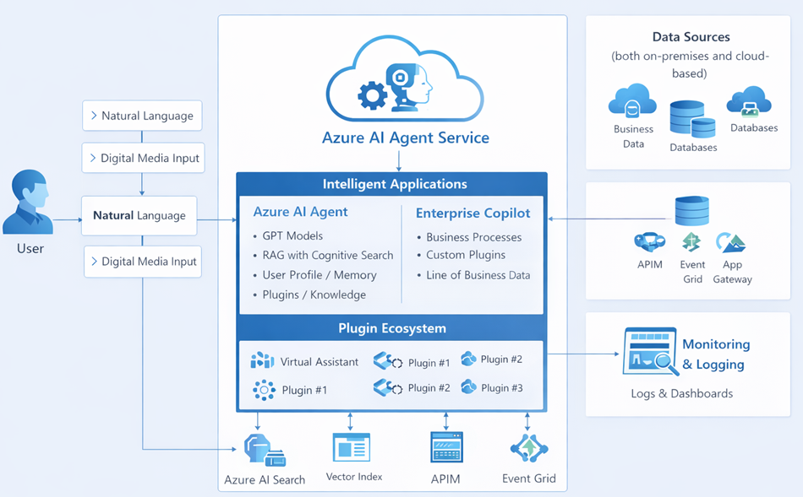
Figure: Reference architecture of Azure AI Agent Service
Essential capabilities of the Azure AI Agent Service are as follows:
- Effortless Agent Creation: Developers can set up intelligent agents with minimal coding or configuration effort. By using Azure AI Python or .NET SDKs, one can select the desired AI model (such as GPT-4), define the agent’s objectives with tailored instructions, and specify which tools the agent may access. The platform itself manages model deployment and tool orchestration, allowing developers to focus on business logic rather than infrastructure.
- Seamless Integration with Azure OpenAI and External Tools: Agents operate using the same interfaces as Azure OpenAI Assistants, enabling them to connect effortlessly with a wide array of tools and plugins. With access to over 1,400 Logic App connectors, agents can interact with SaaS applications, databases, and more. Furthermore, they are capable of executing Azure Functions for bespoke logic or complex data processing. This versatility means agents can work with Microsoft 365 applications, trigger internal APIs, or even run Python scripts in a secure environment for tasks such as data analysis.
- Versatile and Expandable: The service is not restricted to conversational tasks alone; agents are equipped to handle transactions and automate workflows. Azure AI Agent Service accommodates connections to external tools via OpenAPI standards, and can integrate open-source agent frameworks like Microsoft Semantic Kernel or LlamaIndex with cloud-scale enhancements. This flexibility allows agents to gain new functionalities simply by adding tools—for example, connecting to a SharePoint MCP endpoint for document retrieval or using a translation API to convert outputs as needed.
- Built-in Security and Governance: Given their role in accessing sensitive enterprise systems, Azure AI Agent Service is designed with robust security at its core. Operating within the trusted Azure Foundry environment, it leverages Azure Active Directory for authentication and can enforce OAuth 2.1 authentication and governance policies automatically. Standardised activity logs and error handling ensure transparency and facilitate monitoring, which is vital for maintaining trust in automated AI solutions.
Consider a scenario where an agent autonomously collects sales data from various sources, cleanses it, applies business rules, and generates actionable insights for business analysts. The agent can handle exceptions, notify stakeholders, and maintain logs for audit purposes.
Sample Agent Script:
# Pseudocode for Azure AI Agent Service
agent = AzureAIAgent()
agent.connect(source='SalesDB', target='AnalyticsLake')
agent.ingest()
agent.transform(rules='cleanse, deduplicate')
agent.analyse()
agent.notify('BusinessTeam')

Multi-Agent Orchestration in Azure
Traditionally, automation has relied on a single script or service to execute a fixed set of steps in sequence. In contrast, the new paradigm of multi-agent orchestration offers much greater flexibility. Here, several AI agents, each possessing their own area of expertise, can work together dynamically to accomplish complex objectives. Azure is adopting this approach, empowering organisations to design orchestrations where AI agents can seamlessly transfer tasks, share relevant context, and collaboratively tackle challenges that would be too much for one agent to handle alone. This approach is particularly valuable in data engineering and analytics, where specialised agents can be tasked with individual subtasks—such as fetching data, conducting analysis, preparing documentation, or supporting decision-making—ensuring that each aspect is handled by the most capable agent.
Microsoft has enabled these multi-agent capabilities by bringing together Fabric Data Agents and Microsoft Copilot Studio, which serves as the platform for developing custom Copilot solutions. In the middle of 2025, Microsoft introduced a preview feature that allows agents to communicate directly with each other within Copilot Studio, using the Model Context Protocol (MCP). To put it simply, this means an agent built in Fabric—such as one designed for data analysis—can now coordinate with an agent in Microsoft 365 Copilot—like an assistant for Office documents—through a standardised protocol, making it possible for them to work together efficiently.
This mirrors how people collaborate in teams, as complex workflows often require input from various specialists or tools at different stages. By emulating this team-based approach, AI agents can deliver true end-to-end automation across multiple systems. For example, consider a business scenario such as “preparing a sales report and organising a review meeting.” One agent could be responsible for analysing sales data, another for drafting the required documents, and a third for managing the scheduling of meetings. Multi-agent orchestration enables these different agents to work together smoothly, handing off tasks as needed.
Coordinating multiple AI agents to accomplish intricate, interconnected tasks is at the heart of multi-agent orchestration. On Azure, this is realised through orchestration frameworks that oversee agent communication, assign tasks, and manage errors. Each agent can function on its own or in cooperation with others, thereby improving both scalability and system resilience.
To implement multi-agent orchestration in practice, tools such as Azure Logic Apps, Durable Functions, or the Azure AI Agent Service can be employed. Within this setup, each agent is given a defined responsibility—such as extracting data or assessing quality—while the orchestration layer oversees the process to ensure everything runs smoothly from start to finish.
Example scenario: Microsoft illustrated this with a vision of an automated enterprise workflow:
- Agent A (Fabric Data Agent) – “Finance Data Agent,” which can pull real-time sales figures from the enterprise data lake (OneLake) and understand the data context (e.g., knows fiscal year definitions, sales hierarchies).
- Agent B (Office 365 Copilot) – a “Proposal Drafting Agent” in Word that can compose documents.
- Agent C (Microsoft 365 Assistant) – an agent that can schedule meetings in Outlook and update CRM entries.
This is illustrated as a workflow architecture in below diagram for your easy understanding.
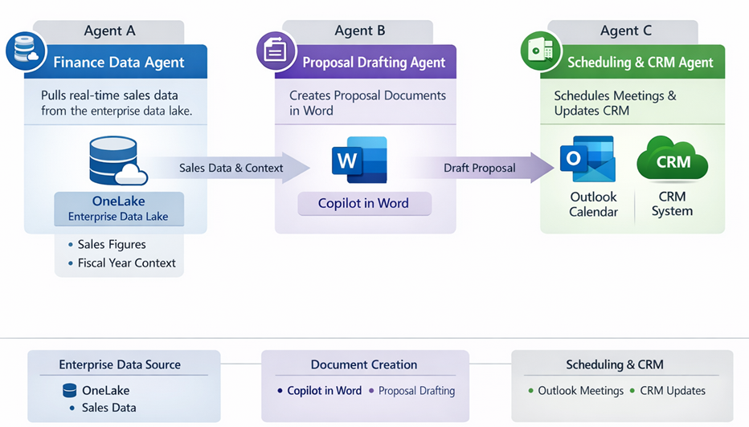
Figure: Automated Enterprise workflow architecture
The Finance Data Agent (Agent A) first gathers the latest sales numbers and perhaps performs some analysis (year-over-year growth, regional breakdowns). It then calls Agent B to draft a Word document: a sales proposal slide deck or report, embedding the data and insights Agent A provides. Once Agent B finishes the document, Agent C is engaged to email the report to stakeholders and put a follow-up meeting on everyone’s calendars. This kind of cross-agent handoff was not possible with earlier, isolated bots, but with Azure’s new multi-agent orchestration support, it becomes a reality.
The coordination is made possible by the Model Context Protocol (which we will detail later) and Azure’s Copilot Studio interface for chaining agents. In Copilot Studio’s orchestration designer, one can specify multiple agents and their interactions in a straightforward YAML or JSON configuration. For example, a YAML snippet below conceptualizes an agent orchestration with two agents: one Fabric data agent and one custom inventory agent, designed to work together in a supply-chain scenario:
1 agents:
2 - name: "SalesDataAgent" # Fabric Data Agent to fetch sales data
3 type: "Fabric"
4 endpoint: "https://api.fabric.microsoft.com/salesdata"
5 - name: "InventoryAgent" # Custom agent (perhaps using Azure Functions) to check inventory
6 type: "Custom"
7 logic: "AzureFunction"
In this setup, a SalesDataAgent might first retrieve the latest sales figures by calling Fabric’s data APIs, then invoke the InventoryAgent (via Copilot Studio’s orchestration) to ensure there is enough stock to fulfill incoming orders . Together, they automate a normally multi-step process: the sales agent provides context to the inventory agent, which checks inventory and maybe triggers a restock if needed.
Embracing this multi-agent approach unlocks a range of exciting opportunities in the fields of data engineering and analytics:
- Integrated Cross-Domain Analytics : For instance, with Copilot’s capabilities, multiple data agents from diverse functions such as finance, marketing, and sales can collaborate within a single conversation. This means that when an executive raises a query, different agents can independently fetch data from finance and sales, reconcile any discrepancies, and synthesise the findings. The end result is a comprehensive and unified perspective that goes beyond what any single data source could provide on its own.
- Intelligent Automated Data Workflows : Agents can work together to automate complex data pipeline activities. One agent may handle the extraction and preparation of data from source systems, and then seamlessly notify another agent to load this data into a warehouse or initiate a machine learning model. Such dynamic collaboration offers far greater flexibility than traditional, rigid ETL processes, giving rise to smarter and more adaptive data pipelines.
To sum up, orchestrating multiple agents within Azure recognises that no single AI model or agent can address every challenge. By coordinating several specialised agents as a cohesive “AI team” using Azure’s robust infrastructure, organisations can shift from inflexible, predefined workflows to adaptable, agent-led processes that reflect the future of data pipeline design.
Here is a sample Orchestration Script to orchestrate multiple agents.
# Pseudocode for orchestrating multiple agents
orchestrator = AzureAgentOrchestrator()
orchestrator.add(agent1, task='ExtractData')
orchestrator.add(agent2, task='ValidateData')
orchestrator.add(agent3, task='EnrichData')
orchestrator.execute()

Agentic Data Pipelines
In Microsoft Fabric, the conventional ETL and ELT pipelines are increasingly being superseded by agentic data pipelines. These innovative pipelines use AI-driven agents to independently manage extraction, transformation, and loading of data. As a result, they offer greater flexibility and adaptability, enabling them to respond effectively to changes as they occur in real time.
The advancement in AI agent intelligence and autonomy has paved the way for what is now referred to as “agentic data pipelines.” Unlike traditional ETL or ELT processes, where data engineers meticulously defined every step for data movement and transformation, agentic pipelines are designed to think, adapt, and make decisions on the fly. Previously, these pipelines consisted of a fixed chain of operations—such as copying data from the source, cleaning it, integrating it, and then loading it into the target system. If there were any changes in the source data—for example, the addition of a new column or an unexpected data quality issue—the pipeline could either fail or yield incorrect results unless engineers intervened and updated the logic accordingly.
The core objective of agentic data pipelines is to leverage AI agents for dynamic management of data ingestion and transformation, thereby minimising the necessity for frequent human involvement. A notable example of this direction is Microsoft’s acquisition of Osmos in January 2026—a startup specialising in AI-powered data preparation. Microsoft’s integration of these capabilities into the Fabric data engineering suite is aimed at streamlining and automating complex, labour-intensive data workflows. Ultimately, the vision is to empower Microsoft Fabric’s OneLake platform with autonomous AI agents capable of ingesting, cleansing, and transforming data—ushering in an era of “autonomous data engineering” within the platform itself.
To contrast the traditional vs. agentic approach, consider the following:
Traditional ETL/ELT Pipelines | Agentic AI-Driven Data Pipelines
Rigid sequence of predefined tasks (hard-coded transformations). | Dynamic sequence of AI-driven steps that can adapt at runtime.
Requires engineers to anticipate all data issues and schema changes up front. | AI agents detect anomalies or schema changes and adjust processing (or ask for guidance) on the fly.
Scaling requires significant manual coding and scheduling of jobs. | Scaling handled by agent platform – can spin up parallel agents as needed, with cloud-managed orchestration.
Limited ability to handle unstructured data or unforeseen scenarios without additional coding. | Naturally handles unstructured or varied data by leveraging language understanding (e.g., parses free text logs, JSON with unknown fields).
Primarily relies on human-defined rules for data quality (e.g., regex validations). | Can leverage AI for data quality – e.g., an agent can learn patterns to detect outliers or cleanse data (removing PII, standardizing formats) in more sophisticated ways.
Examples: A nightly job that copies CSV exports from one system to another and transforms column formats. | Examples: An AI agent that continuously monitors an API for new data, auto-maps incoming fields to a target schema using a learned mapping, fixes minor errors (like typos or unit mismatches) using a language model, and loads data into OneLake in near real-time.

An agentic pipeline essentially operates as a virtual data engineer within software, capable of making informed decisions regarding data management. For example, when confronted with missing values in a dataset, a conventional pipeline may simply discard such rows or fail altogether, unless the developer has specifically programmed an alternative solution. In contrast, an agentic pipeline can intelligently decide to address these gaps, such as leveraging an AI service to estimate missing values or seeking clarification from a human when necessary. This capacity for logical reasoning and adaptability is what characterises it as agentic in nature.
Osmos’s technology, which will soon be integrated into Microsoft Fabric, serves as a prime example of this approach by employing artificial intelligence to map and convert data from external partners into a company’s internal schema. Many organisations routinely receive data from third parties in diverse formats, making the task of aligning this information to internal databases both laborious and constantly evolving. Osmos has introduced AI-driven mapping agents that observe existing data mapping practices and learn to automatically adapt new datasets accordingly. For instance, if a firm regularly imports sales leads from multiple partner CRM systems, an Osmos agent can learn the specific format of each partner's export file and convert it to fit the internal schema, handling variations such as differing date formats or product code conventions. The agent effectively acts as a junior data engineer, learning to integrate new sources by example. It is capable of tasks like column alignment, data type conversion, dropdown value matching, and even conducting semantic checks, such as flagging unexpected entries in a “Country” field—all with minimal human intervention.
Microsoft envisions these AI-enhanced pipelines as tools that will significantly reduce the manual workload data teams face in data preparation and cleansing. According to their official announcement, “By integrating Osmos technology into Microsoft Fabric, we will help data teams turn raw data into analytics and AI-ready assets faster, reduce manual effort, and unlock more value from their data.”
Nonetheless, it is crucial to recognise that agentic pipelines enhance, rather than replace, human oversight. Data engineers will shift from manually crafting every SELECT and JOIN command to overseeing AI agents, verifying their output, and providing direction in exceptional cases. This means routine tasks—such as connecting to data sources, managing minor schema modifications, and performing basic anomaly detection—can be entrusted to AI, allowing human experts to focus on strategic decision-making and governance. This collaborative dynamic between human intelligence and AI-driven automation stands as a defining feature of the post-AI landscape in data engineering.
Within Microsoft Fabric, AI agents are capable of monitoring incoming streams of data, applying necessary transformations, and loading outputs into analytical storage—all executed without the need for explicit coding. This approach not only shortens development timelines but also ensures that pipelines are optimised for AI applications.
Here is the example Agentic Pipeline pseudo code for Microsoft Fabric:
# Agentic pipeline in Microsoft Fabric
pipeline_agent = FabricDataAgent()
pipeline_agent.monitor('incoming_stream')
pipeline_agent.transform('auto')
pipeline_agent.load('OneLake')

MCP Integration with Multiple Data Sources
As AI agents proliferate, a major challenge is connecting them to the right data and tools in a robust, standardized way. Enter Model Context Protocol (MCP) – an open standard co-developed by Microsoft and the AI community (including companies like Anthropic) that has quickly gained traction as the “universal adapter” for AI integration . MCP’s motto is “connect once, integrate anywhere,” meaning that a data source or service only needs to implement an MCP-compliant interface one time, and then any AI agent (with an MCP client) can interact with it without custom coding.
In the MCP architecture, a Host (the AI agent or assistant) contains a generic Client component that knows how to speak the MCP protocol, and an external system (database, application, etc.) runs an MCP Server that exposes certain actions or data. The MCP server essentially wraps the external system’s API or queries into a standard format. When an agent needs something from that system, it sends a request via the MCP client, which the MCP Server receives, executes (e.g., runs a SQL query or fetches a SharePoint file), and then returns the results in a normalized format the agent can understand . The beauty is that once, say, a SQL Database MCP server exists, any compliant AI agent can query that SQL database without being explicitly programmed in T-SQL by the end user. The translations and security checks are handled by the MCP layers.
Microsoft has been proactively developing and promoting MCP connectors to support a wide range of data services:
- There are official MCP servers either already available or being created for several Azure services, enabling agents to manage Azure resources directly. Similar connectors are also in place for GitHub, allowing agents to carry out repository operations, for Playwright to facilitate web browsing, for Microsoft Teams to assist with collaboration in chats, for Dev Box, and most significantly, for Azure AI Foundry itself—thus providing agents centralised access to all the capabilities within Azure AI Studio.
- Additionally, the open-source community and third-party developers have contributed MCP servers for platforms such as SQL Server, PostgreSQL, Google BigQuery, file systems, and SharePoint. For instance, a dedicated “SQL Server MCP” can expose selected tables or stored procedures to an AI agent, thereby permitting secure query execution and result retrieval. Similarly, a SharePoint MCP allows an agent to fetch documents or perform searches on a SharePoint site as needed; for example, an AI assistant could locate the onboarding guide in SharePoint in response to a user’s request, leveraging MCP to fetch the relevant file.
These MCP integrations address a longstanding challenge: enabling AI to securely and meaningfully access enterprise data and tools. Previously, each integration required bespoke development and intricate API work. Now, organisations can simply deploy an MCP server—whether self-hosted or cloud-managed—and use it across a variety of AI applications. To support this, Microsoft offers software development kits (SDKs), such as an official MCP SDK for C#, which simplify the process of building these connectors. They also provide guidance on exposing existing REST APIs as MCP servers using Azure API Management, ensuring that crucial elements like OAuth security and monitoring are incorporated.
For example, if a company wants its internal AI assistant to answer queries using data from its on-premises SQL Server and to perform specific actions in SharePoint, it can deploy an MCP server for each platform. The SQL Server MCP server might provide a queryDatabase tool that receives T-SQL commands and returns the results, while the SharePoint MCP could offer a searchDocuments function. The AI assistant, acting as the MCP Host, does not require built-in knowledge of SQL syntax or SharePoint’s API; it communicates via the MCP client, which handles the intermediary work. Thus, when a user inquires, “What were our top 10 products by revenue last quarter?”, the agent can translate this into a query for the SQL MCP server. Subsequently, if the user requests, “Please upload this chart to the Portal,” the agent can use the SharePoint MCP’s uploadFile or postDocument function to save the chart on SharePoint—all within a single, fluid conversation. The MCP architecture manages authentication, encryption, and error handling, eliminating the need for custom integration code from developers.
Looking ahead, MCP is poised to serve as the essential link for connecting diverse data sources within agent-driven workflows. In fact, as reported by Visual Studio Magazine in late 2025, Microsoft introduced the “Azure Cosmos DB MCP Toolkit” to integrate its NoSQL database with Foundry Agent Service scenarios. This enhancement enabled AI agents to conduct vector searches and transact with live Cosmos DB data, thereby extending operational database access to multi-agent systems. In essence, MCP is transforming the way AI accesses heterogeneous data, making it as simple as invoking a function—an important leap in AI integration across complex enterprise landscapes.
Microsoft Cloud Platform (MCP) thus facilitates smooth integration with a variety of data sources, including SQL Database and SharePoint. Through MCP, data engineers can connect, extract, and unify data from multiple platforms, ensuring both consistency and accessibility.
Here is the pseudo code script for MCP integration to connect to SQL database and Sharepoint.
# Connecting SQL Database and SharePoint
mcp_connector = MCPConnector()
mcp_connector.connect_sql('SalesDB')
mcp_connector.connect_sharepoint('Documents')
mcp_connector.unify()
Integration ensures that data from operational systems and document repositories is available for analytics, reporting, and AI-driven insights.

Evolution of Microsoft Fabric
Microsoft Fabric has undergone significant development, introducing innovative tools such as Fabric Copilot, Data Agents, and Copilot Studio. Fabric Copilot guides users through the process of creating data pipelines, generating code, and resolving errors, thereby simplifying complex tasks. Data Agents are designed to automate repetitive activities, enabling teams to boost efficiency. Meanwhile, Copilot Studio provides a collaborative workspace where users can design, launch, and manage AI-powered solutions together.
Launched in 2023, Microsoft Fabric emerged as a comprehensive analytics platform that unified data engineering, warehousing, data science, real-time analytics, and business intelligence. Its initial focus was on eliminating data silos by offering a single SaaS environment for tasks ranging from data extraction to Power BI dashboard creation, all anchored by OneLake, Fabric’s cloud-based data repository. As the platform evolved in the age of artificial intelligence, Fabric transformed into a robust ecosystem enriched with conversational Copilot features and intelligent agent capabilities. The following outlines this progression:
The history of Microsoft Fabric reveals a steady increase in AI integration:
- Fabric Copilot allows users to interact with their data using everyday language across the platform’s experiences. For instance, within Power BI, Copilot can generate DAX formulas or create narrative descriptions for reports. In Data Factory, it helps construct pipeline expressions and recommends data transformations. This capability makes advanced analytics more accessible by reducing reliance on coding, and it accelerates workflow for experts. Users can simply request, for example, “Generate a dataflow in Fabric to merge sales and marketing data by customer ID,” and Copilot will propose the necessary steps.
- Fabric Data Agents serve as specialised conversational AI assistants for data. Configured on top of Lakehouses or Data Warehouses in OneLake, these agents understand data structure and business context, enabling users to ask questions such as, “What were the total sales in Europe last quarter, and how does that compare to the previous year?” The agent then converts this query into the appropriate SQL or Kusto command, retrieves the data, and presents the results as charts or tables. Building on Power BI’s Q&A feature and enhanced with GPT-like capabilities, Data Agents lower the barriers to analytics, allowing business users to explore data conversationally without needing to write formulas or manipulate fields.
- Copilot Studio and custom agents empower organisations to craft bespoke Copilot experiences—tailored AI assistants that connect with resources like Fabric Data Agents. Demonstrated in 2025, this integration marked the beginning of advanced multi-agent orchestration. For example, a company could develop a “Finance Copilot” that not only responds to questions using corporate financial data through a Fabric Data Agent, but also interacts with SAP to make budget adjustments and drafts approval emails in Outlook. Copilot Studio offers a visual interface to connect these components, and the underlying Microsoft Cloud Platform (MCP) ensures seamless communication between Copilot and Fabric Data Agents. The result is a conversational AI assistant capable of both discussing information and executing tasks based on analytical insights.
Microsoft Fabric’s advancement in the post-AI era is centred on embedding intelligence at every level of its data infrastructure. Users benefit from AI-powered tools like Copilot to enhance productivity, while developers gain a flexible framework—combining Data Agents and Copilot Studio with support for multiple agents—to create new AI-driven applications. By uniting a consolidated data foundation with generative AI technologies, Fabric is positioning itself as a leading platform for AI-ready analytics.

Advanced AI features in Azure OneLake
OneLake, Azure’s unified data lake, now includes advanced AI and security capabilities. AI features enable automated data classification, semantic tagging, and intelligent search. Security enhancements include role-based access, encryption, and anomaly detection.
At the heart of Microsoft Fabric is OneLake, the “one lake for all your data” analogous to OneDrive for files. OneLake provides a single, multi-cloud data lake that is automatically available to every Fabric user and service. In the post-AI era, several new OneLake features have been introduced to enhance how data is accessed, secured, and made AI-ready:
- Unified Access to Data (Shortcuts & Zero-Copy): OneLake introduced data shortcuts, which are pointers to external storage locations. This allows Fabric to virtually connect to data on other cloud storage or on-premises, without moving or duplicating the data. For instance, a shortcut can link an S3 bucket or an ADLS Gen2 container into OneLake, so that Fabric analytics can query it as if it were local. This zero-copy approach reduces data sprawl and ensures that AI or BI tools are always accessing the single source of truth. In parallel, Fabric’s new Mirroring feature (discussed in the next section) enables replicating certain operational data into OneLake in near real-time with minimal effort.
Here is the reference architecture of Azure OneLake with latest features for AI-ready services integrated for unified data solutions.

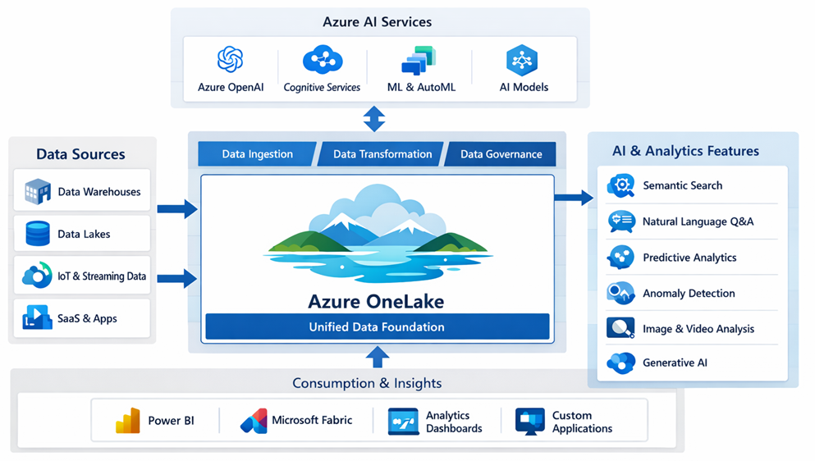
Figure: Reference architecture of Azure OneLake

- Unified Access to Data (Shortcuts & Zero-Copy) : OneLake has introduced the concept of data shortcuts, which act as references to external data storage locations. This innovation enables Microsoft Fabric to seamlessly connect with data stored on other cloud platforms or within on-premises environments, all without the need to move or duplicate the data itself. For example, a shortcut can point to an S3 bucket or an Azure Data Lake Storage (ADLS) Gen2 container, making it possible for Fabric analytics solutions to access and query this data as though it were stored locally. This zero-copy strategy significantly minimises data proliferation and ensures that business intelligence or artificial intelligence tools are always working with the authoritative source of data. Additionally, Fabric’s Mirroring feature, which will be discussed in detail later, provides an easy way to replicate selected operational data into OneLake in near real-time.
- Open Data Formats for AI Compatibility : OneLake relies on open, industry-standard formats like Delta Parquet and Apache Iceberg tables to store data. By using these formats, Fabric ensures that all its processing engines—such as Spark, SQL, data science notebooks, real-time analytics, and Power BI—can access and process the same data without needing to convert it. This standardisation is especially valuable for AI use cases: for instance, a machine learning model might be developed using Spark on curated Parquet data, then deployed, and subsequently used for real-time predictions on streaming data via Kusto, which can read from the same Parquet files. With OneLake, a single copy of data serves multiple engines, streamlining governance and reducing the risk of inconsistencies. This gives data scientists and analysts the confidence that they are working with the most current and centralised data available.
- Granular OneLake Security (Unified RLS and CLS) : One of the most significant advancements in OneLake is its centralised security model. Traditionally, security rules were set up separately for each tool—for example, row-level security in Power BI, explicit GRANTs in SQL pools, or access control lists and filters in Spark—often resulting in inconsistent enforcement. With OneLake Security, data owners can define precise permissions at the folder, table, or even row and column level within OneLake, and these rules are automatically enforced across all parts of Fabric. For example, a data engineer can set permissions such that only certain roles can view records where Department="Finance", or ensure that the Salary column is hidden from everyone except HR managers. Whether the data is accessed through a Spark notebook, an SQL query, or a Power BI report, the OneLake Security layer guarantees these restrictions are upheld. This unified approach greatly reduces the complexity of managing permissions and the risk of inconsistent access, making it especially valuable for organisations committed to strong data compliance.
Leveraging OneLake Security, a data owner can set fine-grained access controls at various levels—folders, tables, or even specific rows and columns—and these controls are consistently applied by all Microsoft Fabric components. For instance, it is possible to restrict access to rows where Department="Finance" or mask sensitive salary data, ensuring only HR managers can view it. Regardless of whether the data is accessed via Spark, SQL, or Power BI, these security rules remain enforced. This approach substantially lessens the management burden and the risk of inconsistent permissions, making OneLake transformative for organisations striving to maintain data compliance across diverse platforms.
- Integration with Microsoft Purview for Governance : In addition to enhanced security, Microsoft has strengthened the integration between Purview—its data governance and catalogue platform—and Fabric. Purview can now scan and index datasets, lakehouses, and other artefacts in Fabric, supporting classification and lineage tracking. Recent updates (as of late 2025) allow for even deeper scanning and governance of Fabric’s assets.
The OneLake data catalogue, accessible through the Fabric portal and powered by Purview, enables all users to discover data assets, review their schemas and descriptions, and understand their lineage—that is, the origin of the data and its transformation journey—in a single, unified interface. This comprehensive catalogue is essential in the era of AI, as it ensures that AI-driven insights and decisions are based on trusted and well-documented data. Furthermore, Purview’s sensitivity labels and data loss prevention (DLP) policies can now be directly applied to Fabric data assets.
For example, if a particular column in a dataset is marked as Confidential, Purview can automatically prevent AI Copilot from exposing that information in chat responses, either by masking the data or blocking access to it altogether. This close integration between governance and AI capabilities reflects Microsoft’s commitment to responsible AI practices—a topic that will be explored further in subsequent sections.
AI-Ready Data Sharing and Collaboration : Beyond centralising organisational data, OneLake simplifies secure data sharing across departmental boundaries. The introduction of domains and workspaces within OneLake mirrors organisational structures and ownership, ensuring proper governance. Data can be shared using shortcuts or direct links, and the unified security and catalogue make it easy for, say, a data scientist in one team to safely find and request access to another team’s dataset for a machine learning initiative. This not only encourages collaboration on AI projects but also breaks down data silos, all while maintaining robust, domain-specific governance.
With OneLake Security, a data owner can define fine-grained permissions once on the folders, tables, or even rows/columns in OneLake, and those rules will be enforced uniformly by all Fabric components. For example, a data engineer could specify that only certain roles can see rows where Department="Finance" or mask out the Salary column for all but HR managers. If that data is accessed in a Spark notebook, a SQL query, or a Power BI report, the OneLake Security layer will ensure the restriction is applied in each case. This dramatically reduces the risk of inconsistent permissions and simplifies the security management overhead. OneLake is a game-changer for organizations that struggle to maintain data compliance across different tools.
- Unified Access to Data (Shortcuts & Zero-Copy) : OneLake has introduced the concept of data shortcuts, which act as references to external data storage locations. This innovation enables Microsoft Fabric to seamlessly connect with data stored on other cloud platforms or within on-premises environments, all without the need to move or duplicate the data itself. For example, a shortcut can point to an S3 bucket or an Azure Data Lake Storage (ADLS) Gen2 container, making it possible for Fabric analytics solutions to access and query this data as though it were stored locally. This zero-copy strategy significantly minimises data proliferation and ensures that business intelligence or artificial intelligence tools are always working with the authoritative source of data. Additionally, Fabric’s Mirroring feature, which will be discussed in detail later, provides an easy way to replicate selected operational data into OneLake in near real-time.
- Open Data Formats for AI Compatibility : OneLake relies on open, industry-standard formats like Delta Parquet and Apache Iceberg tables to store data. By using these formats, Fabric ensures that all its processing engines—such as Spark, SQL, data science notebooks, real-time analytics, and Power BI—can access and process the same data without needing to convert it. This standardisation is especially valuable for AI use cases: for instance, a machine learning model might be developed using Spark on curated Parquet data, then deployed, and subsequently used for real-time predictions on streaming data via Kusto, which can read from the same Parquet files. With OneLake, a single copy of data serves multiple engines, streamlining governance and reducing the risk of inconsistencies. This gives data scientists and analysts the confidence that they are working with the most current and centralised data available.
- Granular OneLake Security (Unified RLS and CLS) : One of the most significant advancements in OneLake is its centralised security model. Traditionally, security rules were set up separately for each tool—for example, row-level security in Power BI, explicit GRANTs in SQL pools, or access control lists and filters in Spark—often resulting in inconsistent enforcement. With OneLake Security, data owners can define precise permissions at the folder, table, or even row and column level within OneLake, and these rules are automatically enforced across all parts of Fabric. For example, a data engineer can set permissions such that only certain roles can view records where Department="Finance", or ensure that the Salary column is hidden from everyone except HR managers. Whether the data is accessed through a Spark notebook, an SQL query, or a Power BI report, the OneLake Security layer guarantees these restrictions are upheld. This unified approach greatly reduces the complexity of managing permissions and the risk of inconsistent access, making it especially valuable for organisations committed to strong data compliance.
Leveraging OneLake Security, a data owner can set fine-grained access controls at various levels—folders, tables, or even specific rows and columns—and these controls are consistently applied by all Microsoft Fabric components. For instance, it is possible to restrict access to rows where Department="Finance" or mask sensitive salary data, ensuring only HR managers can view it. Regardless of whether the data is accessed via Spark, SQL, or Power BI, these security rules remain enforced. This approach substantially lessens the management burden and the risk of inconsistent permissions, making OneLake transformative for organisations striving to maintain data compliance across diverse platforms.
- Integration with Microsoft Purview for Governance : In addition to enhanced security, Microsoft has strengthened the integration between Purview—its data governance and catalogue platform—and Fabric. Purview can now scan and index datasets, lakehouses, and other artefacts in Fabric, supporting classification and lineage tracking. Recent updates (as of late 2025) allow for even deeper scanning and governance of Fabric’s assets.
The OneLake data catalogue, accessible through the Fabric portal and powered by Purview, enables all users to discover data assets, review their schemas and descriptions, and understand their lineage—that is, the origin of the data and its transformation journey—in a single, unified interface. This comprehensive catalogue is essential in the era of AI, as it ensures that AI-driven insights and decisions are based on trusted and well-documented data. Furthermore, Purview’s sensitivity labels and data loss prevention (DLP) policies can now be directly applied to Fabric data assets.
For example, if a particular column in a dataset is marked as Confidential, Purview can automatically prevent AI Copilot from exposing that information in chat responses, either by masking the data or blocking access to it altogether. This close integration between governance and AI capabilities reflects Microsoft’s commitment to responsible AI practices—a topic that will be explored further in subsequent sections.
- AI-Ready Data Sharing and Collaboration : Beyond centralising organisational data, OneLake simplifies secure data sharing across departmental boundaries. The introduction of domains and workspaces within OneLake mirrors organisational structures and ownership, ensuring proper governance. Data can be shared using shortcuts or direct links, and the unified security and catalogue make it easy for, say, a data scientist in one team to safely find and request access to another team’s dataset for a machine learning initiative. This not only encourages collaboration on AI projects but also breaks down data silos, all while maintaining robust, domain-specific governance.
The OneLake data catalogue, accessible through the Fabric portal and powered by Purview, enables all users to discover data assets, review their schemas and descriptions, and understand their lineage—that is, the origin of the data and its transformation journey—in a single, unified interface. This comprehensive catalogue is essential in the era of AI, as it ensures that AI-driven insights and decisions are based on trusted and well-documented data. Furthermore, Purview’s sensitivity labels and data loss prevention (DLP) policies can now be directly applied to Fabric data assets.
For example, if a particular column in a dataset is marked as Confidential, Purview can automatically prevent AI Copilot from exposing that information in chat responses, either by masking the data or blocking access to it altogether. This close integration between governance and AI capabilities reflects Microsoft’s commitment to responsible AI practices—a topic that will be explored further in subsequent sections.
- Unified Access to Data (Shortcuts & Zero-Copy) : OneLake has introduced the concept of data shortcuts, which act as references to external data storage locations. This innovation enables Microsoft Fabric to seamlessly connect with data stored on other cloud platforms or within on-premises environments, all without the need to move or duplicate the data itself. For example, a shortcut can point to an S3 bucket or an Azure Data Lake Storage (ADLS) Gen2 container, making it possible for Fabric analytics solutions to access and query this data as though it were stored locally. This zero-copy strategy significantly minimises data proliferation and ensures that business intelligence or artificial intelligence tools are always working with the authoritative source of data. Additionally, Fabric’s Mirroring feature, which will be discussed in detail later, provides an easy way to replicate selected operational data into OneLake in near real-time.
The diagram below presents the reference architecture for Azure OneLake, highlighting its latest features that support AI-ready services and deliver unified data solutions.
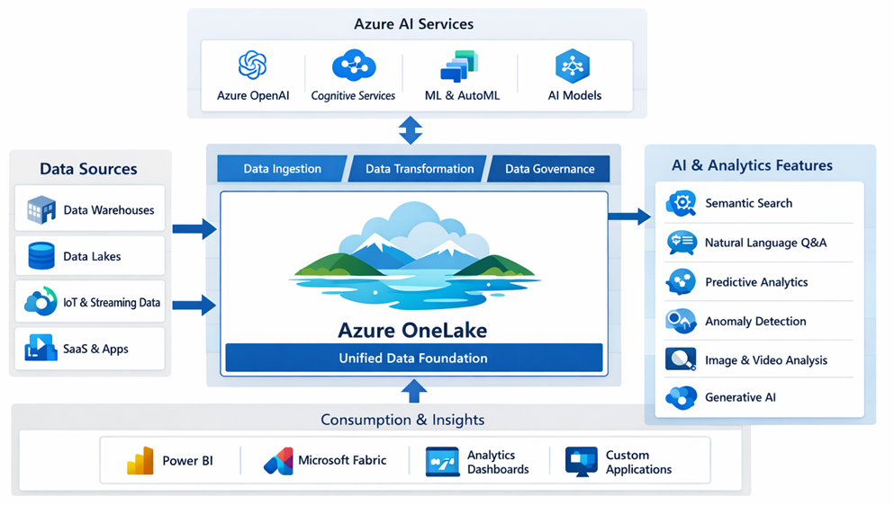
Figure: Reference architecture of Azure OneLake
- Open Data Formats for AI Compatibility : OneLake relies on open, industry-standard formats like Delta Parquet and Apache Iceberg tables to store data. By using these formats, Fabric ensures that all its processing engines—such as Spark, SQL, data science notebooks, real-time analytics, and Power BI—can access and process the same data without needing to convert it. This standardisation is especially valuable for AI use cases: for instance, a machine learning model might be developed using Spark on curated Parquet data, then deployed, and subsequently used for real-time predictions on streaming data via Kusto, which can read from the same Parquet files. With OneLake, a single copy of data serves multiple engines, streamlining governance and reducing the risk of inconsistencies. This gives data scientists and analysts the confidence that they are working with the most current and centralised data available.
- Granular OneLake Security (Unified RLS and CLS) : One of the most significant advancements in OneLake is its centralised security model. Traditionally, security rules were set up separately for each tool—for example, row-level security in Power BI, explicit GRANTs in SQL pools, or access control lists and filters in Spark—often resulting in inconsistent enforcement. With OneLake Security, data owners can define precise permissions at the folder, table, or even row and column level within OneLake, and these rules are automatically enforced across all parts of Fabric. For example, a data engineer can set permissions such that only certain roles can view records where Department="Finance", or ensure that the Salary column is hidden from everyone except HR managers. Whether the data is accessed through a Spark notebook, an SQL query, or a Power BI report, the OneLake Security layer guarantees these restrictions are upheld. This unified approach greatly reduces the complexity of managing permissions and the risk of inconsistent access, making it especially valuable for organisations committed to strong data compliance.
On the whole, the latest enhancements in OneLake establish it as a robust foundation for enterprise AI initiatives—a single platform where all data resides (or is virtually accessible), stored in open formats compatible with AI and machine learning tools, and protected by consistent security and governance mechanisms to prevent misuse.
Sensitive financial data is now automatically classified, tagged, and subject to strict access controls. Any unusual access patterns trigger security alerts, ensuring that your data remains safeguarded at all times.

Mirroring Databases to OneLake
Azure now supports mirroring of databases such as Azure SQL Database, Cosmos DB, and PostgreSQL to OneLake. This eliminates the need for complex ETL processes, allowing real-time synchronisation and simplified analytics. This is explained in below reference architecture diagram.
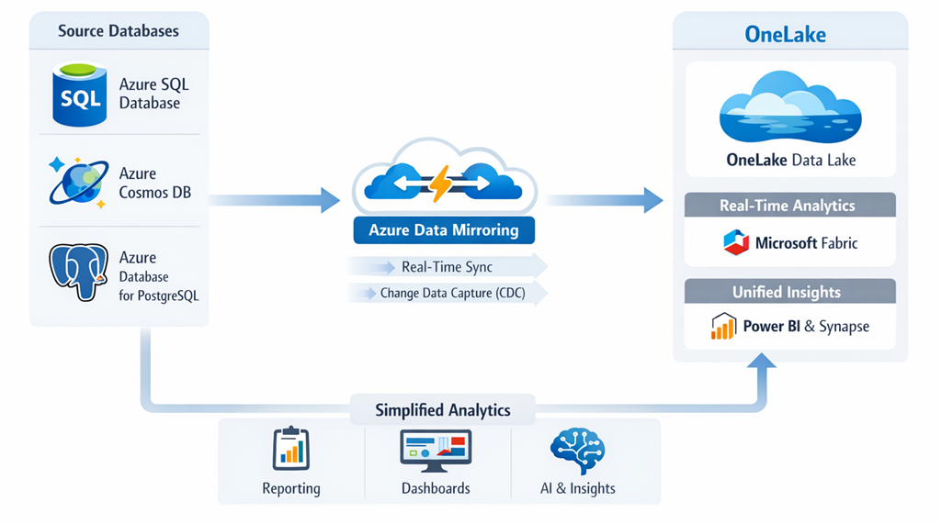
Figure: Real-time synchronisation in Azure Data Mirroring
Continuing the focus on breaking down data silos and reducing manual ETL workloads, Microsoft has introduced Fabric Mirroring—a technique often referred to as “zero-ETL” ingestion. The primary aim of mirroring is to enable seamless, real-time replication of information from operational databases into OneLake, all with minimal configuration and no need to construct complicated data pipelines. At present, Fabric Mirroring supports sources such as Azure SQL Database, Azure Cosmos DB, Azure PostgreSQL, and even Snowflake, with plans to expand support for additional data platforms in the future.
When a mirror is established, Fabric sets up a direct connection to the source database and takes care of both the initial data snapshot and ongoing change tracking automatically. This is typically accomplished using technologies like change feeds or transaction logs—for example, Cosmos DB’s native change feed or SQL’s Change Data Capture (CDC)—to continuously stream updates from the source to OneLake in near real time. The data is written to OneLake as Delta tables (Parquet files) within a dedicated Mirrored Lakehouse, which directly corresponds to the original database. Both the structure and content of the data remain synchronised; so, if new tables or columns are introduced at the source, those modifications are promptly reflected in the mirrored Lakehouse. This automatic synchronisation is a marked improvement over traditional ETL processes, which generally require manual intervention whenever the schema changes.
As the mirrored data is stored in Delta/Parquet formats, it is immediately accessible for high-performance queries by Fabric’s analytical engines. Microsoft highlights that this enables scenarios such as using Direct Lake mode in Power BI, which eliminates the need for import or direct query operations, since the data is already available in an efficient, columnar structure within the lake. The result is the capability to conduct analytics and AI on live operational data without resorting to complex ETL jobs.
Example scenario: Consider a retail company that wishes to analyse sales transactions stored in an Azure SQL Database alongside customer data housed in Azure Cosmos DB (a NoSQL service). Typically, the company would need to build a pipeline to routinely export, transform, and join data from both systems in a data warehouse or data lake. With Fabric Mirroring, mirrors can be configured for both the Azure SQL Database and the Cosmos DB (using its API for MongoDB, for example). Fabric then automatically creates and manages two mirrored Lakehouses within OneLake—one for each source. As new sales transactions are recorded in SQL and customer records are added in Cosmos, those changes are continuously and automatically synchronised into OneLake’s Delta tables. Analysts and data scientists can easily query both datasets together within Fabric. For instance, a single T-SQL query might join sales orders from the SQL mirror with customer details from the Cosmos DB mirror to produce a consolidated report—something previously only possible by exporting and merging data from separate systems. Mirroring thus provides a near real-time, unified perspective of data across diverse stores, positioning Fabric as the central hub.
To maximise efficiency and reduce system overhead, Mirroring leverages cloud-native change feeds. The initial synchronisation transfers all historical data, after which only incremental changes (new or updated records) are kept in sync on a continuous basis. This approach ensures OneLake remains nearly up to date at all times. Furthermore, since the data is readily available in OneLake, advanced analytics and AI models can be applied instantly. For example, a Fabric data science notebook could be used to train a machine learning model on the most recent sales and customer data without any separate data export process. Essentially, mirroring replaces the “extract” phase in ETL, as data integration professionals have observed: it provides continuous extraction built into the platform, allowing users to focus on transformation and analysis.
Handling schema changes and errors
Mirroring is built to be resilient. If the source schema changes (like a new column added), the mirror can propagate that change to OneLake without breaking the pipeline. And if there’s an issue (say the destination is unreachable), Fabric provides monitoring and status of the mirror in the workspace, so you can see lag or errors and address them. This reduces the maintenance effort compared to custom ETL, where engineers often don’t find out about failures until someone notices missing data.
Current limitations
Mirroring is still a relatively new feature (introduced in preview in late 2024 and reaching general availability by 2025). It initially supports Azure sources (SQL DB, Cosmos, PostgreSQL, etc.) and some external databases like Snowflake, with more to come. It also requires Fabric’s premium capacity and certain configurations (for example, Azure SQL DB must not have certain features like its own CDC or Synapse Link enabled, to avoid conflicts). Despite these limitations, the promise of eliminating ETL for many scenarios is extremely attractive. In one blog, the author calls mirroring “game-changing… ensuring your data is always up-to-date for advanced analytics, AI, and data science, all without the complexity of traditional ETL processes”.
By using mirroring in conjunction with other OneLake features (like shortcuts for external data and the unified security model), organizations can significantly simplify their data architecture. Data from operational stores flows into the analytics lake in (near) real time, ready to be consumed by BI reports, SQL or Spark queries, and machine learning models – without writing a single data pipeline. This drastically shortens the time it takes to get value from data, supporting real-time decision making and AI applications like up-to-the-minute personalized recommendations or anomaly detection on live business operational data.
Mirroring Script Example:
# Mirroring Azure SQL Database to OneLake
mirror_service = AzureMirror()
mirror_service.source('AzureSQL')
mirror_service.target('OneLake')
mirror_service.enable_realtime()
This capability streamlines data consolidation and supports event-driven architectures.

Real-Time Intelligence (KQL)
Azure provides real-time intelligence through Kusto Query Language (KQL), which powers event-driven analytics. Data engineers can analyse streaming data, detect patterns, and generate alerts instantly.
Modern enterprises increasingly need to analyze data as it’s generated, whether it’s server logs, IoT sensor readings, or transactional events. Recognizing this, Microsoft Fabric includes a Real-Time Analytics (RTA) capability – recently rebranded as Real-Time Intelligence – which is essentially a streaming data platform built into Fabric. In the post-AI era, real-time data streams are not just for operational dashboards; they’re feeding directly into AI systems that perform instantaneous analysis, anomaly detection, and decision-making.
A cornerstone of Fabric’s Real-Time Intelligence is its use of KQL (Kusto Query Language), a powerful query language originally developed for Azure Data Explorer (Kusto) and widely used in analytics services like Azure Monitor. KQL is known for its ability to perform blazing-fast aggregations and filtering on large append-only datasets (like logs and time-series data). In Fabric, KQL is the language used to query streaming data in what’s called an Eventstream or Eventhouse, which are components of the Real-Time Analytics offering .
Here’s how it works in Fabric’s Real-Time Intelligence (RTI) with a reference architecture as shown in below diagram.
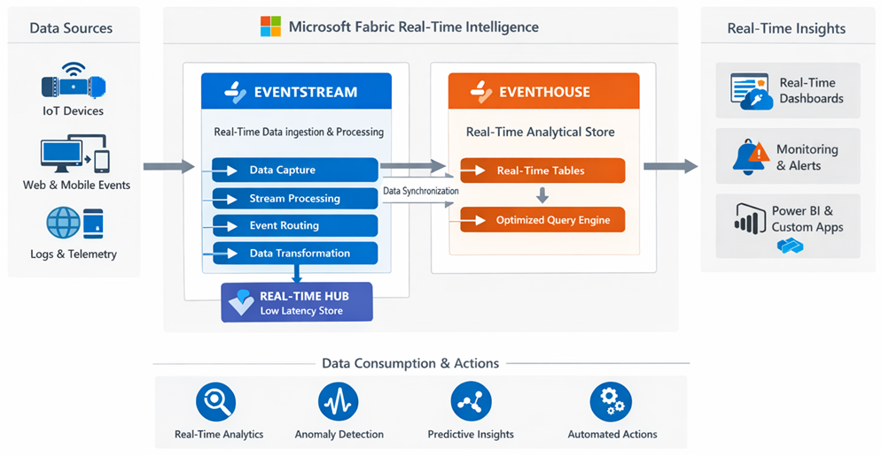
Figure: Reference architecture of Microsoft Fabric Real-time Intelligence (RTI)
- Eventstream: A pipelined service that ingests and processes streaming events. It can connect to numerous sources (via built-in connectors) such as Azure Event Hubs, IoT Hub, Kafka, Amazon Kinesis, MQTT brokers, database CDC feeds (SQL, Cosmos DB, PostgreSQL), and even Fabric’s own internal events . Eventstreams allow you to do streaming ETL – filter or aggregate events on the fly, perform windowing operations, etc., all in a no-code interface if you like. For instance, an Eventstream could ingest clickstream data from a website and compute a rolling 5-minute window of active users by region.
- Eventhouse: A storage and query engine optimized for time-series and log data. Under the covers, Eventhouse is powered by the Kusto engine (the same technology behind Azure Data Explorer and Log Analytics). It automatically organizes incoming data by time, partitions it, and creates indices to allow sub-second queries on high-volume data . Data in an Eventhouse is queryable with KQL, which is well-suited for these scenarios (KQL has succinct syntax for filtering by time ranges, computing moving averages, etc.). Moreover, the data in an Eventhouse can be exposed to other Fabric experiences – for example, you could create Real-Time Dashboards (a new type of Power BI report in Fabric) to visualize streaming data with live updates, or even join real-time data with historical data in a Fabric warehouse.
Event-driven analytics powered by KQL enables use cases like real-time anomaly detection and alerting. For example, consider an IoT scenario: a manufacturing company streams temperature sensor readings from equipment into Fabric. An Eventstream brings in the sensor data from IoT Hub, filters and aggregates it, and lands it in an Eventhouse in real time. An analyst (or an AI agent!) can then write a KQL query to detect anomalies, e.g., find when temperature jumps more than 5 degrees in 1 minute. KQL’s expressive syntax makes this straightforward:
1 EventStreamData
2 | where machine_id == "MachineA"
3 | where TemperatureChange > 5 and AlertSent == false
4 | project Timestamp, machine_id, Temperature, TemperatureChange
This query operates continuously, scanning the temperature data stream for “MachineA” and identifying instances that fulfil the anomaly criteria (such as a temperature rise exceeding 5°C with no alert previously sent). The outcomes of this analysis can be used to power a Real-Time Dashboard, aiding operations teams in ongoing monitoring.
However, Fabric’s capabilities extend further—its Activator feature allows you to define automated, trigger-based actions on streaming data. For example, you can set up an Activator to listen for any results produced by the above query, and automatically initiate an action whenever a relevant record is detected.
Such actions might include sending instant notifications to a team through Microsoft Teams or email, invoking an Azure Function to attempt an automated response (like shutting down an overheating machine), or even engaging an AI agent to assess the situation. In our scenario, if a significant temperature spike is observed, the Activator could prompt an AI Copilot to inform the plant manager and recommend remedial steps—potentially even scheduling a maintenance crew after reviewing historical data on similar incidents.
Beyond this, Real-Time Intelligence in Fabric is also being integrated with Digital Twins and geospatial analytics. The platform offers a Digital Twin builder that enables users to visually model physical environments—such as factories or IoT device networks—using a low-code interface, and map incoming streaming data directly to these digital models.
For example, you could represent a factory floor as a digital twin, defining entities like machines, rooms, and sensors, and then link IoT data streams to these entities. This allows for sophisticated event processing, such as automatically notifying the maintenance team if any machine in Room A overheats. On the geospatial front, Fabric now supports new Map visualisations that can depict real-time data geographically—ideal for applications like fleet monitoring or tracking regional events, complete with features for custom map layers and geocoding.
Fabric’s Real-Time Intelligence suite propels streaming data into the age of artificial intelligence by delivering tools not only to analyse data as it arrives—using KQL and advanced visualisation—but also to respond instantly through automation.
From a data engineering standpoint, the line between traditional batch ETL and real-time streaming is fading. Organisations can now extract and act on critical insights within seconds—an essential capability for AI-driven applications that must always work with the freshest data, such as recommendation engines that adjust in real-time to user behaviour or security models that detect threats the moment they arise.
Altogether, the integration of KQL, real-time processing pipelines, and AI-powered automation forms what Microsoft refers to as Real-Time Intelligence—the capacity to generate and apply actionable insights as events unfold.
Consider a practical scenario in Monitoring IoT devices, detecting anomalies, and updating dashboards in real-time and here is a KQL Example code for the scenario:
# KQL query for real-time event analysis
IoTEvents
| where Temperature > 80
| summarize count() by DeviceID, bin(TimeStamp, 5m)

GraphRAG in Azure Database for PostgreSQL
GraphRAG stands out as a sophisticated approach to retrieval-augmented generation, enhanced by graph-based methods within Azure Database for PostgreSQL. This framework brings together the strengths of graph traversal and artificial intelligence models, enabling richer and more contextually aware outcomes.
As organisations increasingly turned to Retrieval-Augmented Generation (RAG)—where large language models draw on external data to inform their responses—they encountered new hurdles, especially with maintaining accuracy in vast or intricately linked datasets. Traditional methods like keyword or vector similarity searches often struggled in such scenarios. In 2024, Microsoft’s researchers and engineers introduced GraphRAG as an innovative solution to address these issues, enhancing the accuracy of RAG systems by weaving in graph knowledge during retrieval. Azure Database for PostgreSQL emerged as an ideal environment for implementing GraphRAG, as it supports both advanced vector searches and graph queries through its extensions.
GraphRAG, or Graph-enhanced Retrieval-Augmented Generation, elevates standard vector similarity search by bringing in graph-based context. In a typical RAG workflow, such as for a question-answering assistant, documents are embedded and a vector database is used to retrieve those most relevant to a user’s query. However, when the underlying data contains meaningful relationships—such as links between entities—GraphRAG leverages this inherent graph structure to refine the retrieval process. This approach not only strengthens the relevance of the retrieved information but also leads to more precise answers generated by the language model.
Azure Database for PostgreSQL (especially the Flexible Server offering with the Hyperscale variant) supports Postgres extensions like https://learn.microsoft.com/en-us/azure/postgresql/flexible-server/concepts-vector-search (for vector similarity search) and Apache AGE (for graph database functionality using openCypher queries). This means a single database can act as a relational store, a vector store, and a graph store simultaneously – a very powerful combination for building a GraphRAG system .
Microsoft’s sample solution (released as a public preview in November 2024) focused on legal documents. They had a corpus of judicial cases, which naturally reference each other (case A cites case B, etc.), forming a web of legal precedents. They ingested ~500,000 legal case documents into Azure Database for PostgreSQL. Using pgvector, each document was embedded into a vector for semantic search, and using Apache AGE, the citations among cases were stored as a graph in the same database. A GraphRAG-based retrieval pipeline then worked in three stages for any user query:
- Semantic Vector Search: First, a standard vector similarity search finds candidate documents related to the query (for example, retrieving 50 legal cases that might be relevant, based on embeddings of the query and cases). This is done with a simple SQL query using the <=> vector similarity operator provided by pgvector – under the covers, Azure’s pg_diskann index (if enabled) accelerates this search. For example, this returns the top 50 candidate cases for the question, based on neural embedding similarity.

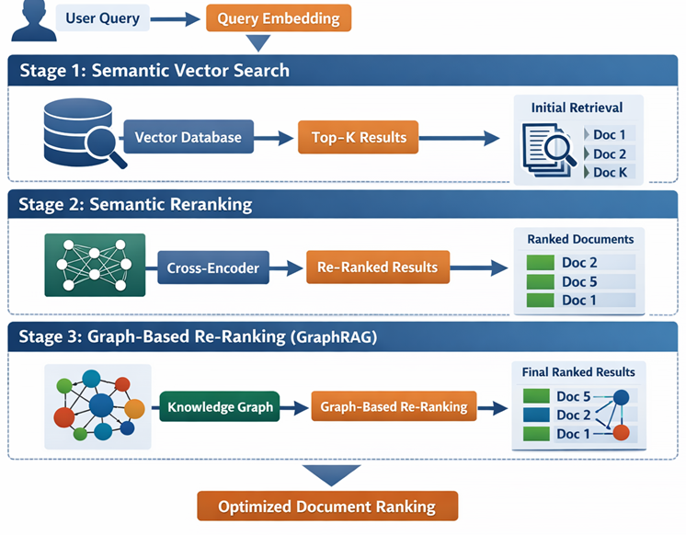
Figure: GraphRAG stages

- Semantic Reranking: Next, the system re-ranks those 50 results using a semantic ranker model (another AI model that scores relevance more accurately, possibly by deeper linguistic analysis) . This step (which can also be done in Postgres via a custom function or in the application layer via an Azure AI service) improves the relevance of the retrieved set, bringing truly pertinent documents to the top.
- Graph-based Re-ranking (GraphRAG): Finally, GraphRAG comes into play. The idea is to use the knowledge graph of case citations to adjust the ranking of results. In the legal domain, the number of times a case is cited by others is a measure of its importance or “prominence.” So among the semantically relevant cases from step 2, the GraphRAG pipeline runs a graph query (using openCypher via Apache AGE in Postgres) to calculate a score for each case based on how connected or prominent it is in the citation network . In practice, they might count how many times each candidate case is cited by other top candidates, or use algorithms like Reciprocal Rank Fusion that combine semantic similarity rank and graph centrality. The result is a re-weighted top 10 list of cases that are both relevant and highly cited.
Once the system identifies the most relevant results, these are passed to the language model, which then crafts the final response—such as a concise summary highlighting key legal precedents related to the query. This process led to a marked improvement in accuracy. With the integration of GraphRAG, the system was notably more adept at pinpointing authoritative cases, thereby minimising the likelihood of the language model referencing less significant or unrelated documents. Microsoft’s evaluations demonstrated that combining vector search, semantic reranking, and GraphRAG significantly outperformed using vector search alone, especially when it came to retrieving the most pertinent “golden” documents for any given query.
Although the legal domain proved an ideal starting point due to its inherent network of case citations, the broader applicability of this method is clear. Organisations across sectors can employ this approach wherever relationships are integral—such as in knowledge graphs connecting concepts like products or customers, or mapping interactions among individuals and departments. Azure Database for PostgreSQL is particularly well suited for this purpose, as it allows both data and their relationships to be managed within a single platform.
For instance, a collection of research articles could be ingested, and a vector search used to identify papers relevant to a specific query. Subsequently, a graph depicting citations or a knowledge graph outlining topics could further refine these results. The ability to perform all these operations directly within Postgres, seamlessly combining SQL and graph queries, offers substantial convenience and power—eliminating the need to operate separate graph and vector databases, and thereby simplifying system architecture.
GraphRAG exemplifies the evolving intersection of artificial intelligence and data engineering. Today, data engineers are increasingly moving beyond traditional flat tables, embracing graph structures and hybrid approaches to better support AI-driven applications. As of 2024–2025, GraphRAG was available as an open-source solution accelerator for Azure PostgreSQL, and it is anticipated that such advanced techniques will become mainstream, perhaps even automated by AI agents, in the near future.
Implementation Example:
# GraphRAG in PostgreSQL
SELECT graph_rag_query('SELECT * FROM nodes WHERE ...');
This approach supports complex knowledge discovery and semantic search.

DiskANN Vector Search (GA) in Azure
The explosion of AI applications – particularly those using embeddings and semantic search – created a need for database systems that can handle vector data efficiently. Vectors (numerical arrays representing semantic meaning of text, images, etc.) are now a first-class citizen in data engineering. Recognizing this, Microsoft has integrated vector search capabilities into its core data services, notably Azure Cosmos DB and Azure Database for PostgreSQL. The “latest developments” here revolve around the general availability of DiskANN, a cutting-edge vector indexing algorithm, in these platforms.
It’s a Disk-based Approximate Nearest Neighbour search library originally developed by Microsoft Research for Bing’s web-scale image search. Traditional vector search methods (like HNSW) keep indexes in memory, which becomes very expensive as vector collections grow into millions or billions of items. DiskANN cleverly stores the index on disk (SSD) in a graph structure optimized for minimal disk seeks. Here is a reference architecture of how DiskANN can be visualized in Microsoft solution for Vector search approach with Azure native data store.
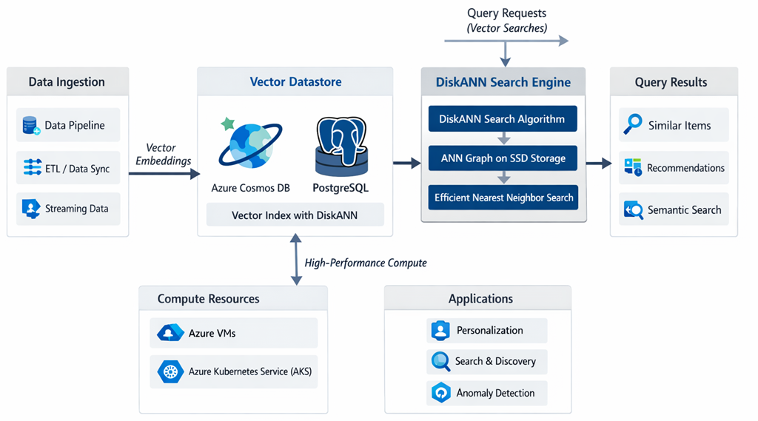
Figure: Reference architecture of DiskANN with Azure native data store
It yields extremely fast search (low latency) even for very large datasets, without requiring enormous RAM. Microsoft reported that, compared to the widely used HNSW approach, DiskANN delivered comparable accuracy with 10× higher throughput, 4× lower cost, and up to 96× reduction in memory usage on a 35-million vector dataset . These are staggering improvements, making it feasible to integrate vector search into operational scenarios at scale.
Azure Database for PostgreSQL: Microsoft added DiskANN as the pg_vector extension pg_diskann in Azure PostgreSQL (currently available in the Flexible Server model). Developers can enable it with a simple SQL command (CREATE EXTENSION pg_diskann CASCADE; which also brings in the base vector type) . Once enabled, you can create a special DiskANN index on a vector column, just like creating an index on a traditional table. For example, if you have a table of products with an embedding vector column, you can do:
1 CREATE INDEX product_embedding_idx
2 ON products
3 USING diskann (embedding vector_cosine_ops);
This creates a DiskANN index (optimized for cosine similarity) on the embedding column of the products table . Now you can perform similarity searches. For instance, to find the top 5 products most similar to a given vector, you might run:
1 SELECT product_id, product_name
2 FROM products
3 ORDER BY embedding <=> '[0.12, 0.03, ... , -0.07]'::vector
4 LIMIT 5;

Note: Here '<=>' is the operator for vector distance (a smaller distance means more similar) and the query vector (in brackets) would be a
DiskANN Vector Search is now generally available in Azure Cosmos DB and PostgreSQL, enabling high-performance, scalable vector similarity searches. This is crucial for AI applications such as recommendation systems and semantic search.
For example,, an e-commerce platform solution can use DiskANN to recommend products based on user behaviour vectors. This is next level of Lead generation for Customer Relationship Management (CRM).
Example Query:
# DiskANN vector search example
SELECT * FROM products WHERE DiskANN(vector) > threshold;

Vector Store/Database Integration with ADF
Azure Data Factory (ADF) now supports integration with vector stores and databases. This allows data pipelines to perform semantic enrichment, similarity searches, and AI-driven transformations.
Pipeline Example:
# Integrating vector store in Azure Data Factory
pipeline = DataFactoryPipeline()
pipeline.add_step('Extract')
pipeline.add_step('VectorStoreEnrich')
pipeline.add_step('Load')
Such integration ensures that data is AI-ready for downstream applications.

Creating AI-Ready Pipelines
Building AI-ready pipelines requires attention to data quality, lineage, and semantic consistency. Azure tools provide automated validation, lineage tracking, and semantic tagging to ensure that data is accurate, traceable, and meaningful.
Example: A pipeline uses validation agents to check for missing values, lineage agents to track data origins, and semantic agents to tag entities.
Sample Code:
# AI-ready pipeline with quality and lineage
pipeline = AIReadyPipeline()
pipeline.validate('quality_rules')
pipeline.track_lineage()
pipeline.semantic_tag('entities')

AI Governance (TRiSM)
AI Governance is vital for ensuring responsible, transparent, and secure use of AI in data engineering. Azure’s TRiSM framework (Trust, Risk, Security, Management) provides guidelines and tools for establishing governance policies, monitoring compliance, and managing risks.
A financial institution implements TRiSM to ensure that AI models are audited, data is protected, and decisions are explainable.
Governance Script Example:
# Applying TRiSM governance
trism = AzureTRiSM()
trism.audit('AIModels')
trism.secure('SensitiveData')
trism.monitor('Compliance')

Conclusion
In the evolving landscape of Azure Data Engineering, the emergence of intelligent agents, self-governing pipelines, and strong governance frameworks has become increasingly significant. Data experts are now expected to harness these advancements by prioritising automation, leveraging real-time analytics, and adhering to ethical AI standards. Keeping abreast of the continual updates within Azure’s ecosystem will help ensure that solutions remain robust, secure, and deliver meaningful results. To effectively incorporate AI-driven Data Engineering within the Azure platform, consider the following best practices:
- Embrace agent-based pipelines to enhance adaptability and strengthen system resilience.
- Unify and manage various data sources efficiently through the use of the MCP framework.
- Utilise real-time data analytics to provide prompt, actionable insights.
- Maintain high standards of data quality and establish clear data lineage to prepare for AI integration.
- Adopt the TRiSM framework to establish robust and reliable AI governance measures.
By adhering to these guidelines, professionals such as data engineers, architects, and developers can confidently steer through the future developments in Azure Data Engineering.

